Guideline Di-Plast Data Analytics Tool

This guideline explains how to install the necessary software for using the Data Analytics tool from the Di-Plast project.

First we need to start with an explanation on how this works; for running the scripts that we use in the analytics tool, a computer should be installed with Python programming language and dedicated packages to execute the scripts for the tool. Please keep in mind that for most of the software that needs to be installed, you need to give permission for the installation.

Step 1: go to https://www.python.org/downloads/ and install the latest python version. Go through each of the steps necessary for using this software. Please click on the “install now” button when using the installation wizard (so not “customized installation”).

For Windows: https://www.youtube.com/watch?v=xXEt9dyvq3U this video explains how to install python. Watch until 3:40.

For Mac: https://www.youtube.com/watch?v=M323OL6K5vs this video explains how to install python. Watch until 2:50.

Step 2: Go to https://java.com/en/download/ and download and install the latest version of java. Go through each of the steps necessary for using the software.

Step 3: To get the EPA tool up and running, we also need the JDK (Java Development Kit) installed on your computer. For this, please visit https://www.oracle.com/java/technologies/downloads/ and download the JDK version suited for your operating system.

Step 4: One final software installation must be done before working with the Data Analytics tools, which is called Anaconda. Go to https://www.anaconda.com/products/individual and install the latest version of Anaconda. Go through each of the steps necessary for using this software. When you see a message concerning the creation of a “PATH”, please check both boxes.

When installation is final, please uncheck both boxes in the installation wizard.

Step 5: Download the files from our Github repository; https://github.com/cslab-hub/Data_Analytics_DIPLAST and place this map on a specific location of your computer. This can be achieved by clicking on the green button saying “code”, which if clicked shows the option to download as zip. It does not directly matter where this .zip file is saved as long as you are able to access it easily. See the figure below for the Github repository.

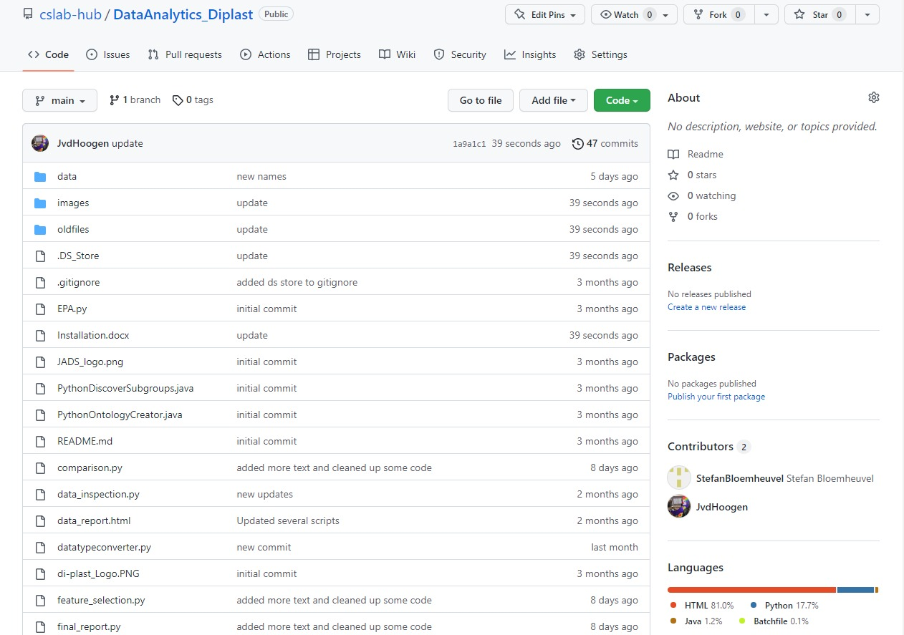

The following files and folders are extracted from our repository and placed on your computer, if you open the .zip file and extract the files. This can be done with applications such as 7zip:

Step 6: Now we will examine the files in this particular folder and explain which steps should be done to open the dashboard. First of all, you see a folder named “data”. This folder contains three example datafiles that can be used for the tool. However, we encourage to add your own datafiles in this folder.

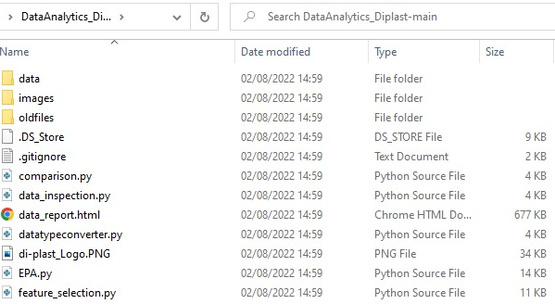

Step 7:
The next step is to install the dependencies of the dashboard and create the virtual environments to run it in. This can be done by double-clicking on the “install_packages.bat” file. This action will automatically open your command prompt, which will create a virtual environment where the dedicated packages will be installed. This might take a few minutes. After that, you can start the dashboard by double-clicking the “start_dashboard.bat” file. This will again open your command prompt and automatically start the dashboard in your browser. Depending on the installation of your computer, there might be a message to allow the browser to start the dashboard.

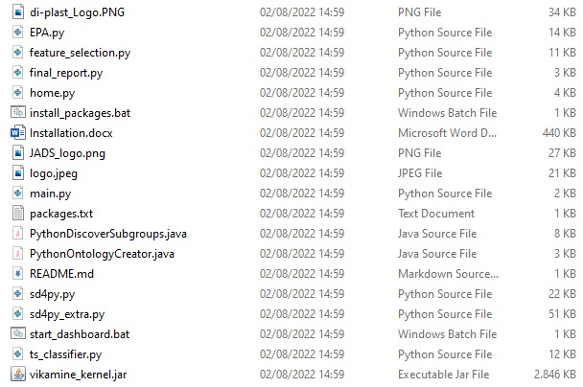
Final remarks:
Now that you successfully went to all the steps, you should see the following dashboard:
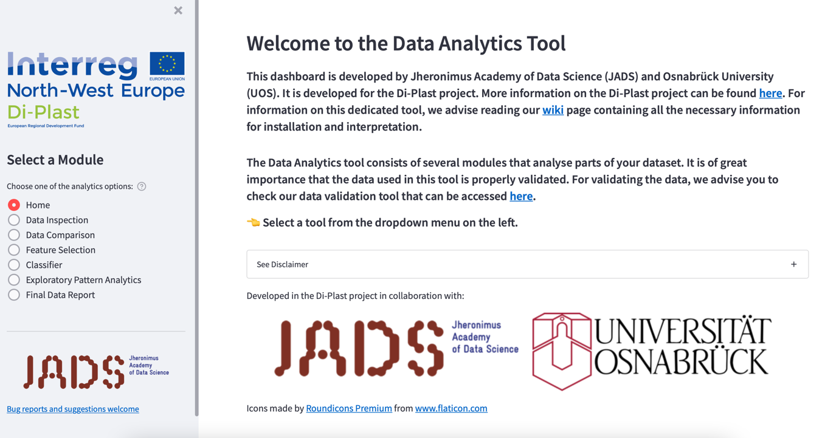

The dashboard can be closed by just removing the browser tab and quit the command prompt. If you want to open the dashboard again, you can click on the “start_dashboard.bat” file again as mentioned in step 6. The other files do not need to be opened again to restart the dashboard.

For any questions, please feel free to contact me on j.o.d.hoogen@jads.nl.

