Understanding and predicting faults in a paper mill production process, using exploratory pattern analytics (EPA)

Despite leading to a loss of output, and therefore being potentially very costly to the business, faults are still common in many production processes. This document will explain how faults can be analysed from sensor recordings using the exploratory pattern analytics (EPA) tool, in order to gain an insight into what happens during a fault and potentially to predict them before they occur. The EPA tool can be applied to sensor recordings to find patterns describing typical situations in which an event occurs. For example, a pattern might be “Blade pressure” is Low AND “Vacuum strength” is High, in which case a fault is likely to have occurred; this pattern gives a concise summary of a typical situation in which there is a fault, making it easier to predict and to understand one particular type of problem.

The remainder of this document will provide a brief demonstration of running an analysis using the EPA tool. The example we will focus upon is a paper mill, which is a production process consisting of several connected steps that ultimately create large rolls of paper. One large sheet of paper is fed through the different machines in succession, which apply necessary processes like extracting moisture or compressing the paper. A common issue is that the sheet of paper breaks during processing, which temporarily halts production. When this happens, the paper must be carefully fed back through the sequence of machines before production can continue, leading to a loss of output before the process is running again. As noted by Ranjan et al.,, this is estimated to be a problem worth billions of dollars across the entire paper industry.

First, let us consider the data we will be using for our demonstration. The paper mill dataset (http://bit.ly/2uCIJpG)^{1,2} is freely available, and contains 60 different sensor recordings from across the production process, with measurements taken every 2 minutes, for a period of a month. In addition, there is a variable which indicates whether there is a fault at each moment in time. Measurements were taken at 18398 time points (2-minute intervals), and there were faults at 124 of these points.

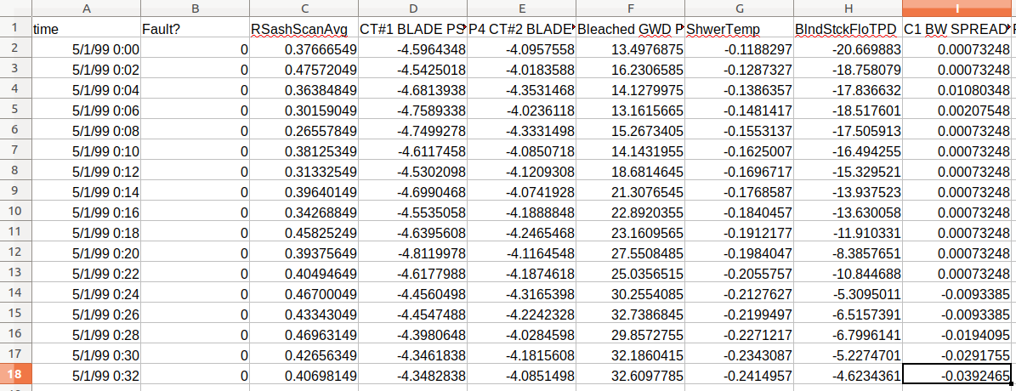Figure 1: Paper mill dataset of sensor recordings

To use the EPA tool, the user will identify some variable of interest (called the ‘target’ variable) and will extract patterns that help to explain that variable. The goal of the EPA process will be to understand in what circumstances the target is extreme. With a numeric target, this means finding circumstances in which the value is exceptionally high (or exceptionally low) on average. For a non-numeric target, this means looking for circumstances when a particular value is especially likely to occur. In our case, the target variable will be the indicator of whether or not a fault has occurred, and we will search for circumstances in which a fault is especially likely.

Alongside the target variable, it is crucial to have other variables that potentially will help to explain the target variable. These should be measurements that naturally accompany the target, and variables that seem irrelevant to the target should be excluded. The paper mill dataset conveniently provides 60 relevant variables from across the production process.

In order to search for patterns that help to predict a fault before it happens, we construct a target variable that indicates whether a fault will begin within the next 10 minutes. Patterns found using this target will describe situations in which a fault is especially likely to occur soon, and this could help an expert gain a better understanding of when faults occur and why.

To understand the EPA tool better, it is worth knowing how patterns are chosen. Patterns identify a ‘subgroup’ of rows within a dataset. The subgroup associated with each pattern can be evaluated according to its size and how extreme the target value is (for example, how likely some event is within the subgroup compared to across the dataset overall). The formula for doing this evaluation is called a ‘quality function’, which will decide the relative importance of the subgroup being large compared to it having a particularly extreme target value. Additionally, it is possible to search for patterns with large subgroups versus searching for patterns with smaller subgroups.

To perform the analysis, the first task is to load the data by selecting it from the drop-down menu in the EPA tool.

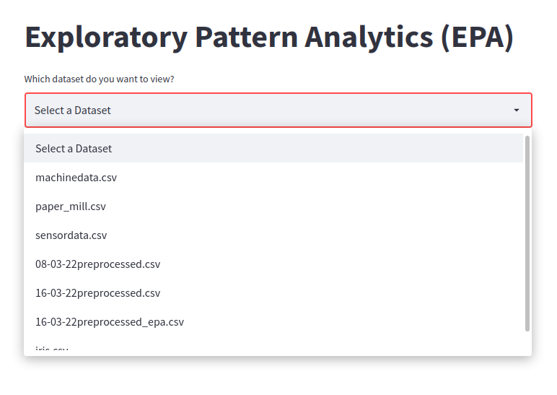Figure 2: Selecting a dataset to analyse
Next, some key options for the pattern search can be provided. The target variable should be specified, and the target value for this variable should also be selected if using a non-numeric target. The quality function can be chosen to favour smaller or larger subgroups, and the minimum size can also be set. Finally, there is an option to remove patterns that select essentially the same subset of data as other patterns, basically removing duplicates in the results.

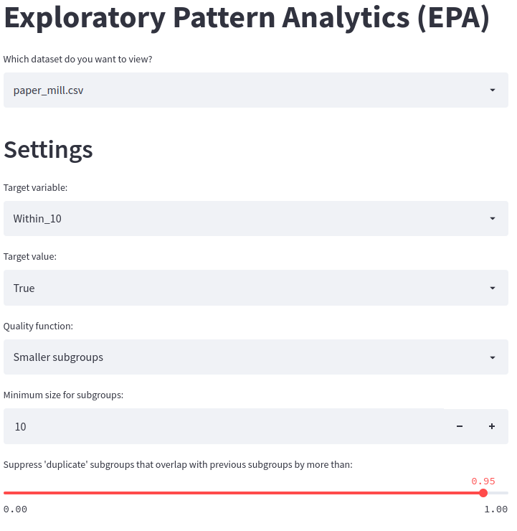Figure 3: Providing settings for the pattern search

In this analysis, patterns for smaller subgroups will be used. Smaller subgroups are potentially interesting because they could point to situations that then commonly lead into a fault (or pose a danger of developing into a fault). Of course, there are multiple reasons why a fault may occur, and these smaller subgroups give a hint about one particular situation (rather than all of the situations) that often leads to a fault.

After selecting parameters, the analysis will run automatically, and the best-performing patterns will be shown in a table.
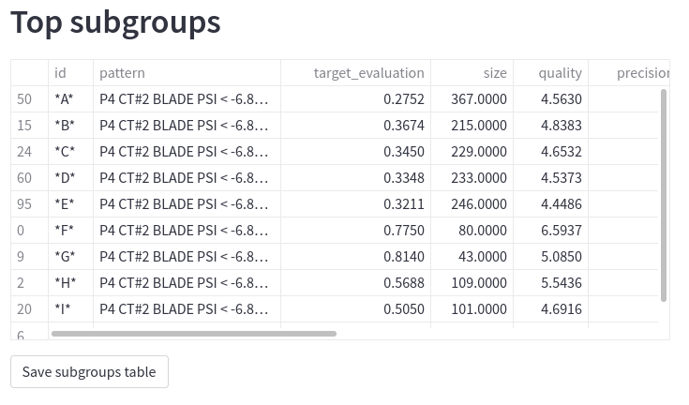Figure 4: Top patterns found by the EPA tool
This table shows various useful pieces of information, including the size of the subgroups found and estimated confidence intervals on various performance metrics. Clicking on the table will expand it to show all the columns. Looking at this table, we find that one of the best patterns is:

- P4 CT#2 BLADE PSI < -6.83
- -5.44 <= COUCH VAC
- RS BW SPREAD MD < 0.91

This suggests, for example, that the blade pressure is low and the couch vacuum is high typically when a fault is likely to occur. An expert could investigate this particular combination of sensor measurements and ask why they are so likely to precede a fault, whether there is a causal relationship, and whether there is any way to reduce the likelihood of a fault developing.

To accompany the table of patterns, there are two extra visualisations that make it easier to compare subgroups. The first shows the expected variability for the target value, meaning how much it changes across different samples of sensor measurements. This is depicted through boxes in a box plot, with wider boxes implying greater variability.

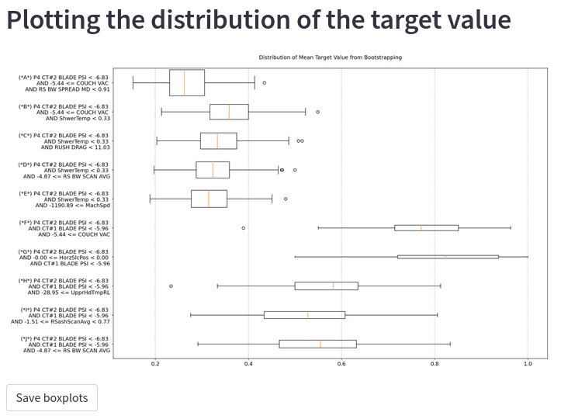Figure 5: Box plots showing how much the target value varies for each pattern
In the second visualisation, patterns are connected to each other by how much their members overlap. If two patterns select similar subsets of data (have similar subgroups), then they have a strong link between them and appear closer together. Overall, this visualisation takes the form of a network diagram.

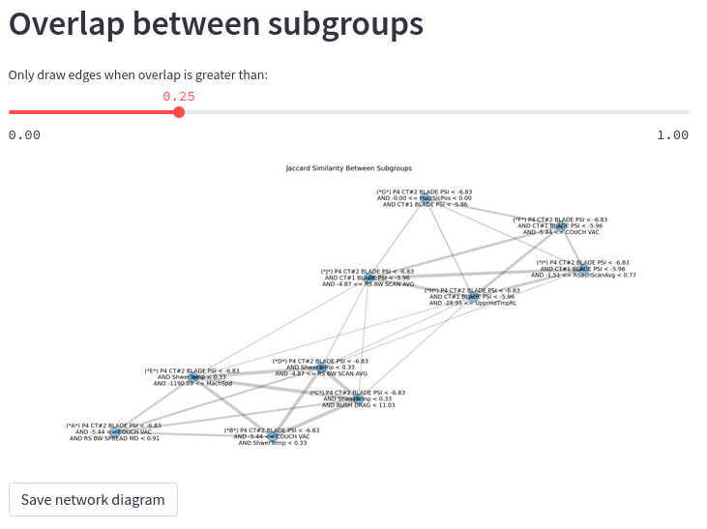Figure 6: Diagram showing overlap between subgroups

At this point, there may be patterns that are particularly interesting. The EPA tool makes it possible to examine these in more detail. A visualisation is provided that compares subgroup members to non-members for one specific pattern. The target variable, the variables used to define the pattern (selector variables), and additional variables that are most clearly different between members and non-members are shown. This makes it possible to see additional information about the pattern, and understand more about the circumstances in which the pattern occurs.

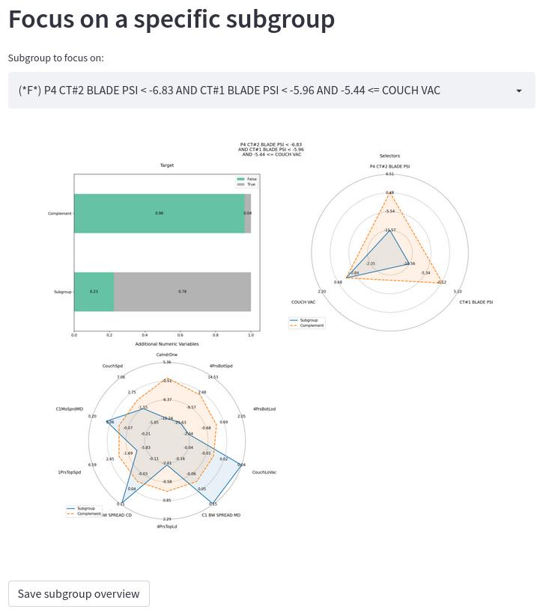Figure 7: Detailed view of a single pattern

Finally, since the paper mill data comes from a process that happens over time, we can focus on particular moments at which a pattern occurs, to see what happens to different sensor recordings before, during, and after. After selecting a single pattern, the user of the EPA tool can then select a particular moment when the pattern occurs, from a drop-down list. The target variable is shown, along with the other variables that are most clearly different between subgroup members and non-members. The moment at which the pattern occurs is indicated by a red rectangle in the background.

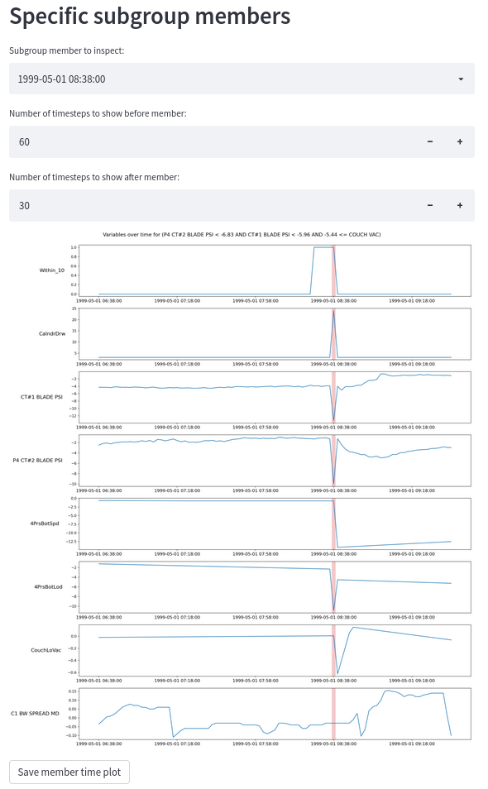Figure 8: Important variables over time for a particular occurrence of the pattern

The examples above should show by now that the EPA tool can find various types of patterns. What these patterns do is inform the user about what the data can tell us about a particular question, in a format that is easy to interpret and understand. In this way, the patterns provide information about what is contained within the data, and they are subject to the limitations of the data. Therefore, it is important that the EPA tool is used in combination with expertise about the subject matter, i.e., experts who understand the sensor recordings and the manufacturing process, who can interpret the outputs of the tool.

One additional thing to note when performing the analysis is that the EPA tool supports an iterative approach. This means that the EPA process can be run to obtain initial patterns, which then might suggest changes like adding or removing variables or refining the search parameters, before re-running the process. When taking this iterative approach, it is best to involve someone who understands the phenomenon being studied and who will be able to make use of the insights provided by the tool.

To summarise: in this demonstration, we have considered the problem of faults within a production process, something that is costly to many manufacturing businesses. The EPA tool was used to identify patterns that help to explain and predict faults within a production process. These patterns provide useful information to an expert who might be trying to diagnose the faults and reduce the likelihood of them occurring. This demonstration has also shown that there are different ways to search for patterns, for example it is possible to look for patterns identifying a larger or smaller subgroup, and it is possible to focus either on moments when a fault is occurring or moments that precede (and potentially predict) a fault. Ultimately, the EPA tool provides insights from the data, to support an expert who is trying to reduce the impact of faults; if the expert is successful, this would imply cost savings to the manufacturer.

Chitta Ranjan (2020). Understanding Deep Learning: Application in Rare Event Prediction. Connaissance Publishing.
Chitta Ranjan, Mahendranath Reddy, Markku Mustonen, Kamran Paynabar, & Karim Pourak. (2019). Dataset: Rare Event Classification in Multivariate Time Series.

